Apache DBUtils 1.0:

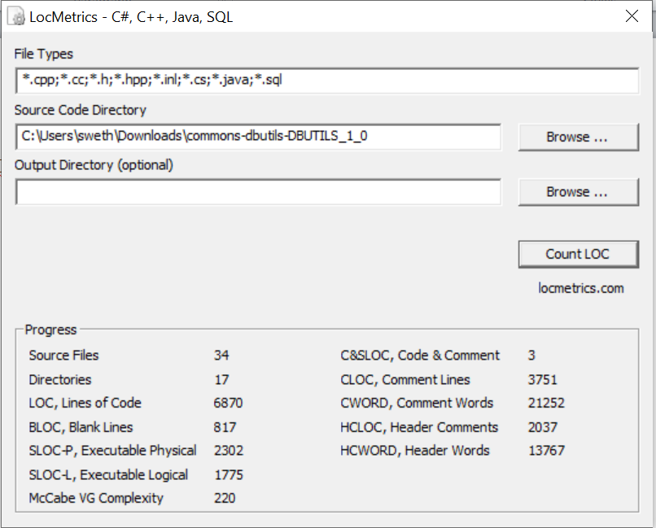

Defect Density = 4/2302 = 0.00173

Apache Commons DBUtils 1.2:

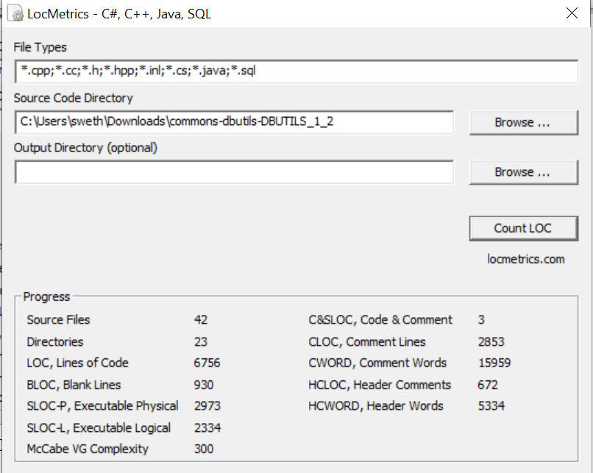

Defect density = 4/2973 = 0.00134

Apache commons DBUtils 1.4:

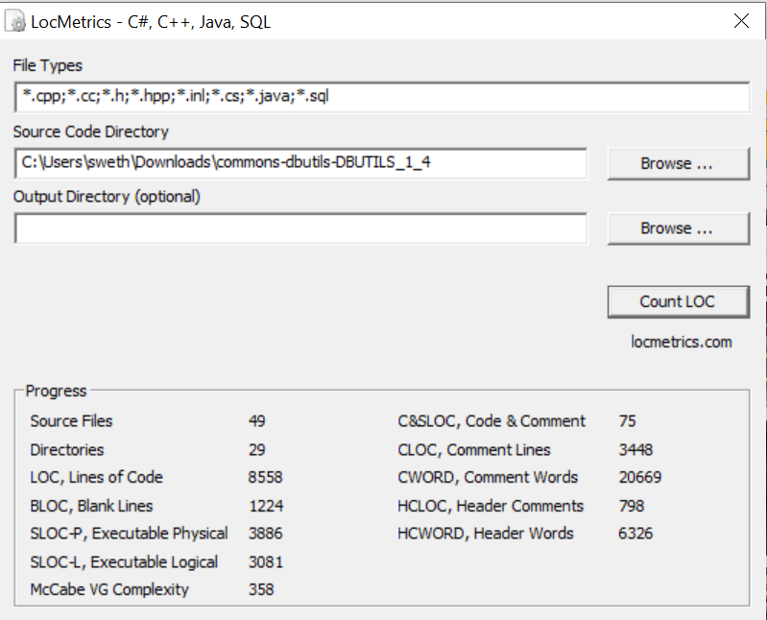

Defect density = 2/3886 = 0.000514

Apache Commons DBUtils 1.6:

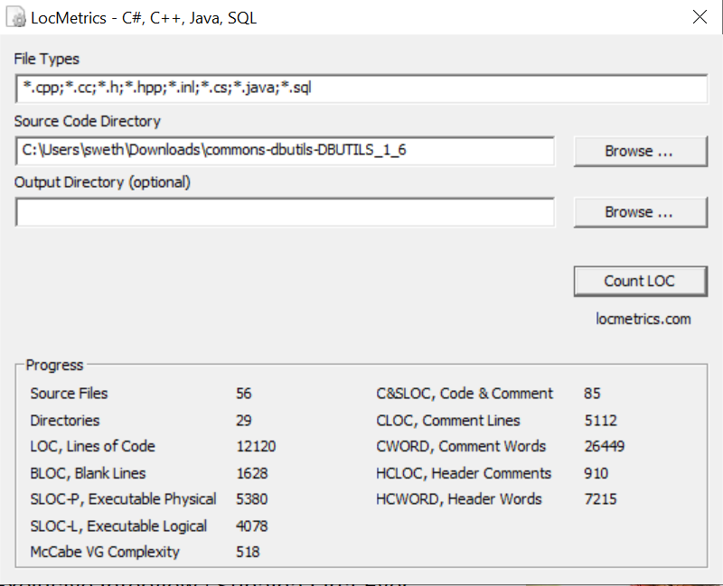

Defect density = 4/5380 = 0.00074

Apache Commons DBUtils 1.7:

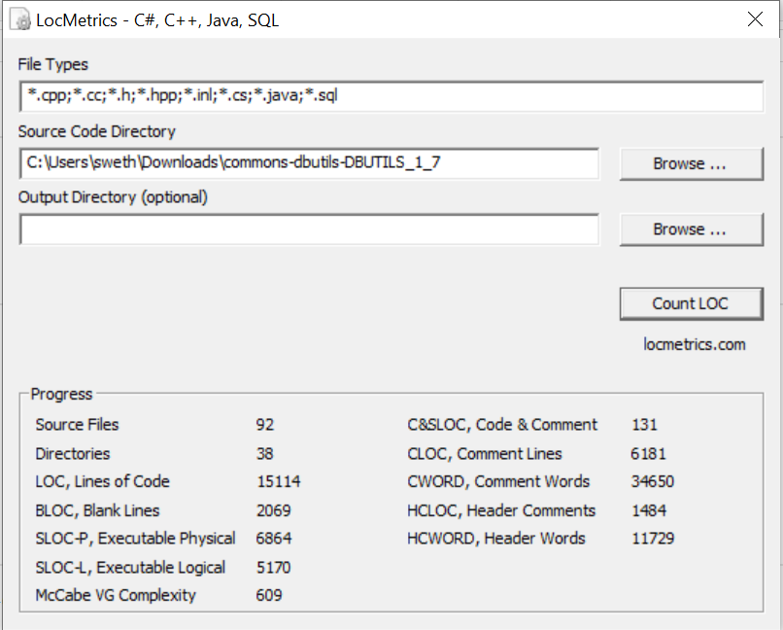

Defect density = 6/6864 = 0.000874

Apache Commons Collections 2.0:

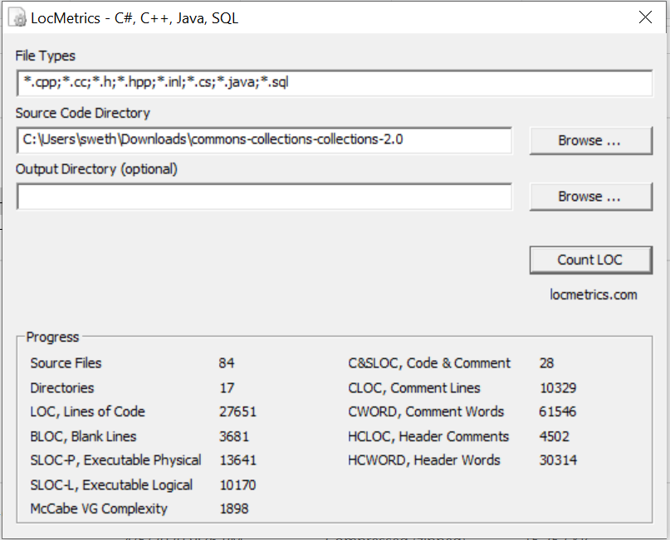

Defect density = 4/13641 = 0.000293

Apache Commons Collections 3.0:

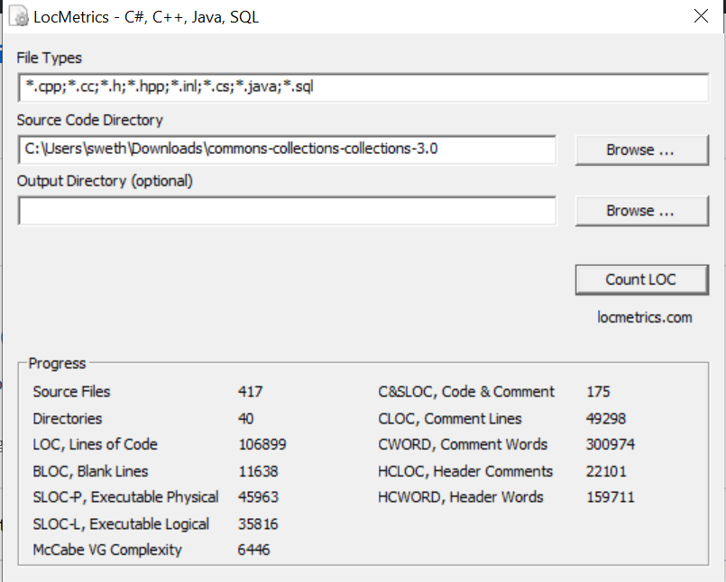

Defect density = 15/45963 = 0.000326

Apache Commons Collections 3.2:

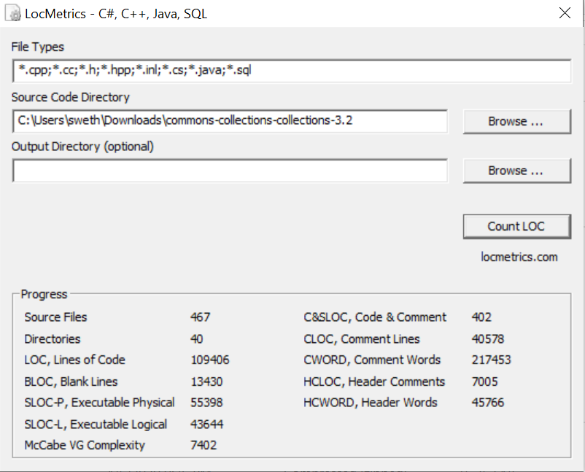

Defect density = 55/55398 = 0.000992

Apache Commons Collections 4.1:

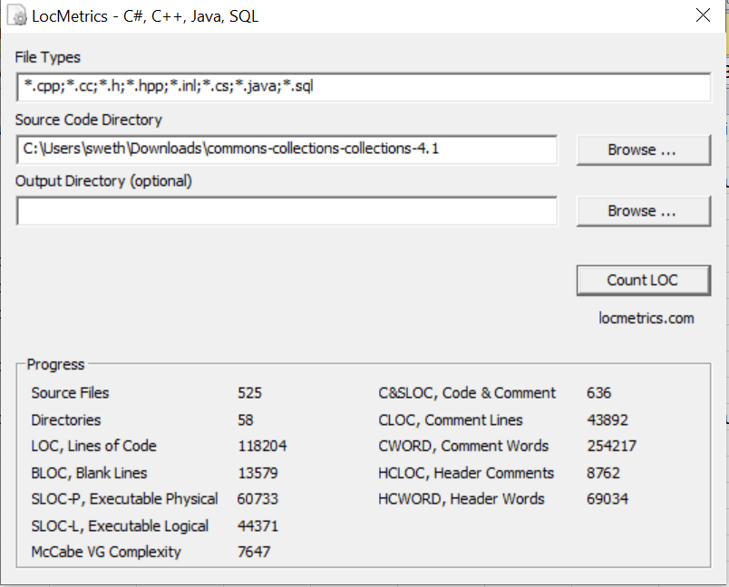

Defect density = 16/60733 = 0.000263

Apache Commons Collections 4.4:

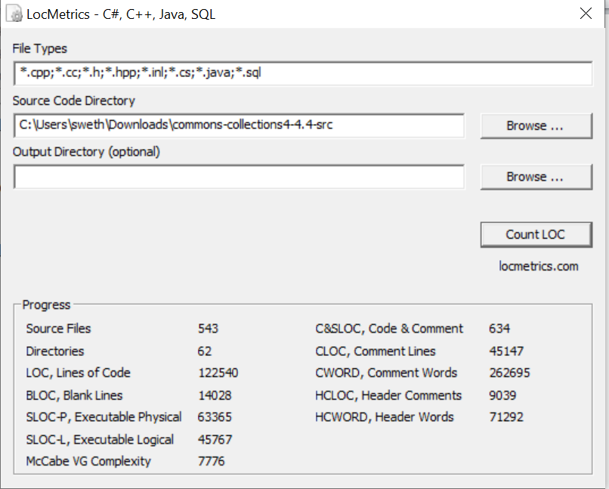

Defect density = 5/63365 = 0.0000789

Apache Commons Configurations 1.8:

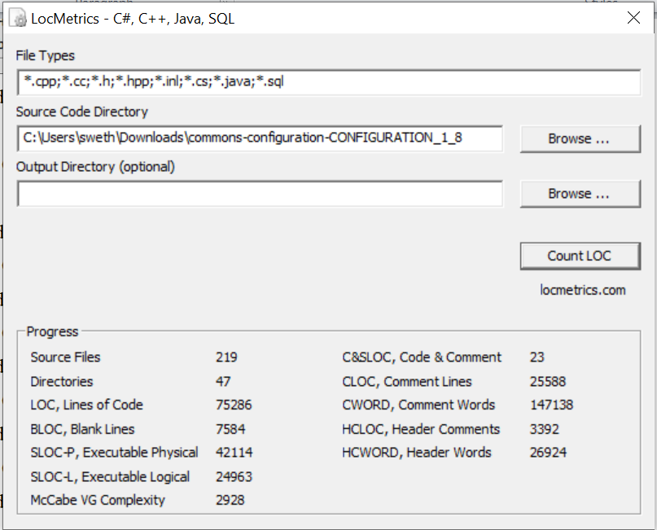

Defect density =16/42114= 0.000379

Apache Commons Configurations 2.0:

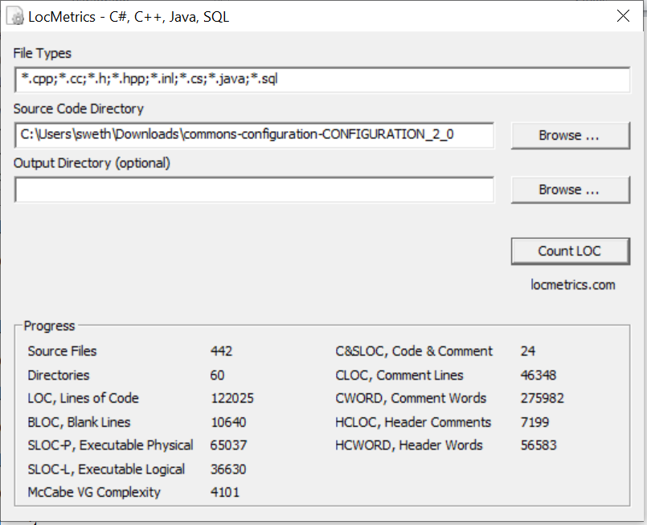

Defect density =11/65037 = 0.000169

Apache Commons Configurations 2.2:

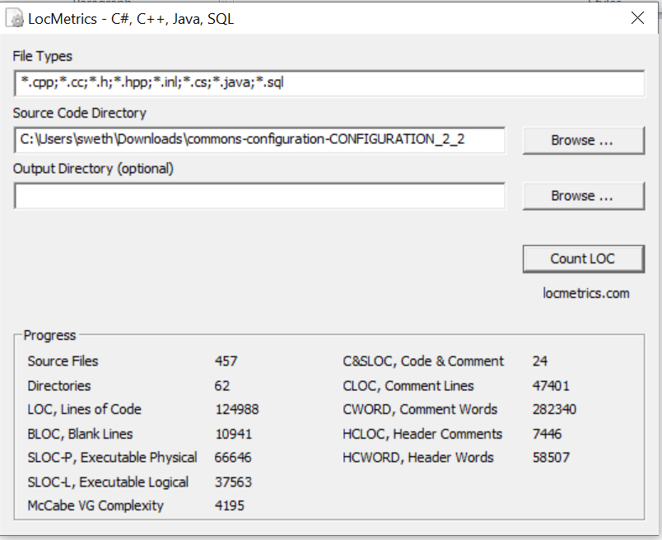

Defect density =7/66646 = 0.000105

Apache Commons Configurations 2.4:

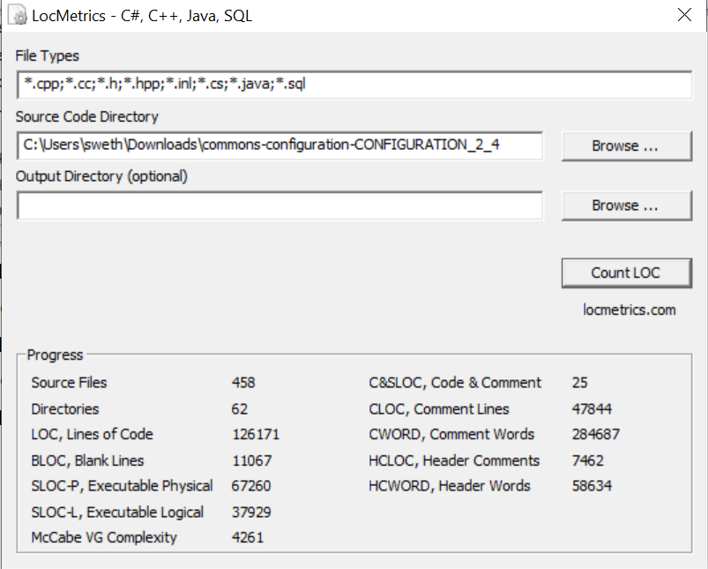

Defect density =2/67260 = 0.0000297

Apache Commons Configurations 2.6:

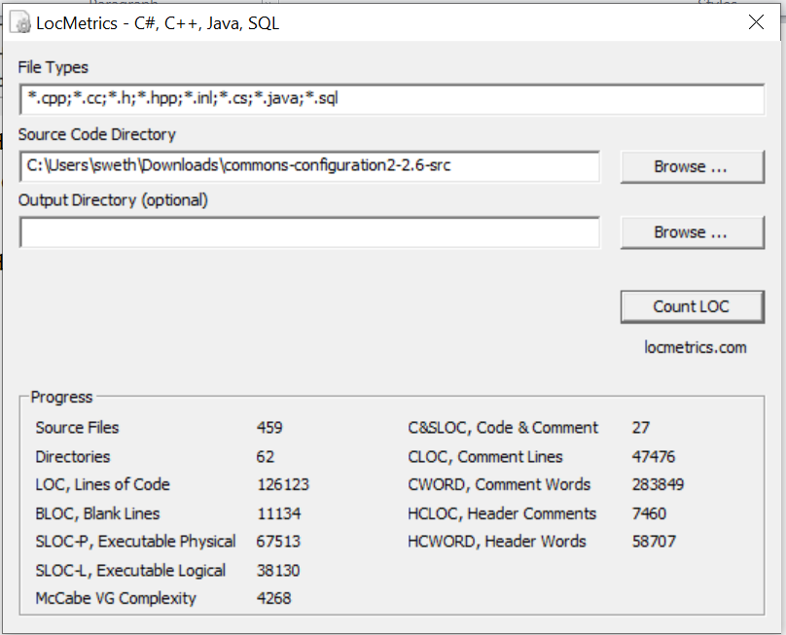

Defect density =4/67513 = 0.0000592